IES Consulting
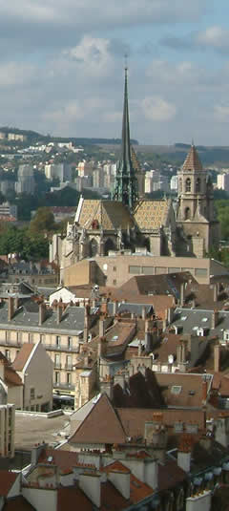
Talent Searchers Providing Experiences

International Receptionist in a luxury Hotel

WHERE? Bourgogne , France
WHEN? Position available from 04.2016
DURATION: 3 months +
HOW MANY HOURS? full time, 40h/week
Magnificent castle located in Burgundy with 24 luxury rooms. 4 * hotel with gourmet restaurant and spa offers luxury service to customers.
The tasks are varied:
Front Desk tasks include:
* Guest service
* Check-in/ Check-out
* Reactivity in order to face unpredictable changes: late check-out, extensions, early departures etc.
* Giving information to hostel guests regarding tourist attractions, leisure activities etc.
* Answering questions regarding hostel offers, facilities and events.
* Handling complaints, suggestions, etc
We are looking for:
- Studies: Tourism, Hospitality, Languages, Business, Marketing , Communication
- Languages: High English and French
- Young, dynamic, proactive, social and energetic profiles are appreciated.
We offer:
- Remuneration: 500€/month + accommodation + food
- Interesting tasks, international and pleasant work environment
APPLY NOW! Please send us your CV in English or French on
interns@ies-consulting.es or
register on our website http://www.ies-consulting.es/internships/student_form.php

* Our recruitment process is free. Only if you got accepted and the company will confirm your application we require administration fee. All our internships provide salary, so we guarantee that costs of the services will pays off.

