IES Consulting – Your internship abroad!
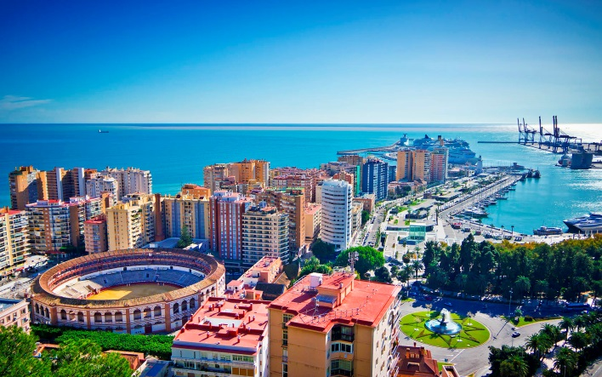
Animation in Malaga
WHERE? Malaga, Spain
WHEN? From 02.2016 on
DURATION: 2-3 months
HOW MANY HOURS? Full-time, 40h/week
Hotel-Apartamentos de 4* ideal para vacaciones combina las ventajas de alojarse en apartamentos con las instalaciones y servicios de un hotel en la Costa del Sol. Frente al mar y a 20 minutos del aeropuerto de Málaga, los apartamentos de están equipados con cocina,salón-comedor, baño y terraza.
The tasks:
- planning and instructing recreational/entertainment program for adults and children
- organisation of activities, games, competitions, sports activities
- animating hotel guests to take part in those activities
- information for guests relating recreational program.
We are looking for:
- Studies: Physical Education, Philology, Tourism etc.
- Languages: HIGH ENGLISH (BASIC SPANISH would be an advantage)
We offer:
- Remuneration: 3€/month + meals + accommodation
- Interesting tasks, international and pleasant work environment
APPLY NOW! Please send us your CV in English or Spanish to
interns@ies-consulting.es with the title Animation MALAGA

* Our recruitment process is free. Only if you get accepted and the company confirms your application, we will require an administration fee. All our internships provide salary, so we guarantee that costs of the service will pay off.

