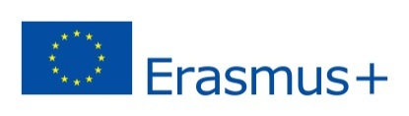
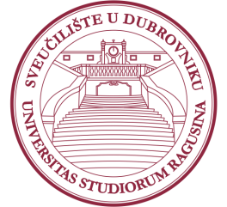
University of Dubrovnik
5th Erasmus+ Staff Week
25 – 29 March 2019

Application Form for Training Mobility
(for non-teaching staff only)

Name/Surname:
Title/Position:
Institution/ City/ Country:
Department/Office at home institution:
E-Mail:
Main responsibilities:
Which activities your institution implemented in the field of “Internationalization at home”. If you have good practice examples in this field, free feel to name them.
Comments/special requirements:

Please send the filled Application form until January 21 2019 to international@unidu.hr.

This Staff week is designed as training, led by Mrs. Justyna Giezynska. Mrs. Giezynska is a higher education internationalisation expert, president of Luminar Foundation and Studybility CEO from Warsaw, Poland. The training will include workshops, round table discussions, brainstorming sessions and presentations of good practices. The working language will be English.
Please note that the places are limited and there is a possibility that we will not be able to accept all applications. We will inform you about the approval of your application by February 4 2019, at latest. After the acceptance confirmations are sent, more details about the final Program will be provided to all participants. Please note that transport and accommodation is a personal responsibility of the selected candidates. In case of any further questions, please do not hesitate to contact:
Mrs. Sandra Memunić (head of IRO): sandra.memunic@unidu.hr; +385 20446041
Mrs. Nikolina Potrebica (Erasmus coordinator): nikolina.potrebica@unidu.hr; +385 20446061

We look forward to welcoming you at the University of Dubrovnik!

