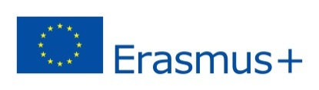
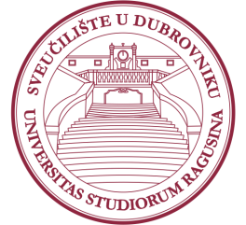
University of Dubrovnik
5th Erasmus+ Staff Week
25 – 29 March 2019

Application Form for Teaching Mobility

Name/Surname:
Title/Position:
Institution/ City/ Country:
Faculty/Department at home institution:
E-Mail:
Scientific Field (e.g. Mathematics, Economics, Engineering etc.):
Name the courses you teach at your home institution:
Comments/special requirements (any special IT equipment should be stated here):

Please send the filled Application form until January 21 2019 to international@unidu.hr.

Please note that the places are limited and there is a possibility that we will not be able to accept all applications. We will inform you about the approval of your application by February 4 2019 at latest. After the acceptance confirmations are sent, more details about the final Program will be provided to participants. Please note that transport and accommodation is a personal responsibility of the selected candidates.
In case of any further questions, please do not hesitate to contact:
Mrs. Sandra Memunić (head of IRO): sandra.memunic@unidu.hr ; +385 20446041
Mrs. Nikolina Potrebica (Erasmus coordinator): nikolina.potrebica@unidu.hr; +385 20446061
We look forward to welcoming you at the University of Dubrovnik!

